MACHINE LEARNING PROJECT REPORT
House Price Prediction Model Using Machine Learning
- Introduction
The field of real estate requires precise assessment of properties when they are being bought, sold, or used for investments. There have been numerous traditional approaches that take time to generate results.

In this research, machine learning (ML) algorithms will be used for predicting house prices based on their attributes like size, quality, room count, and year of construction.

- Problem Statement
Accurately predicting house prices is challenging due to the influence of multiple factors such as location, size, and property condition.

This project aims to:
- Develop a regression-based machine learning model that can predict house prices using structured housing data.

- Objectives
- For performing the analysis of housing data set and knowing about feature interactions
- For preprocessing of raw data
- For applying regression models to perform predictions
- For assessing the model’s performance based on evaluation measures
- For identifying the best performing model

- Dataset Description
The dataset used in this project is the Ames Housing Dataset (from Kaggle).

Features include:
- Overall Quality
- Living Area (sqft)
- Garage Capacity
- Basement Area
- Year Built
- Number of Bathrooms
- Sale Price (Target Variable)

- Tools and Technologies
The following tools and technologies were used:
- Python
- Pandas (Data Processing)
- NumPy (Numerical Computation)
- Matplotlib & Seaborn (Visualization)
- Scikit-learn (Machine Learning)
- Streamlit (Deployment)

- Methodology
- Data Collection
The dataset was obtained from Kaggle and loaded into a Pandas DataFrame. The dataset contains 1460 entries and 81 columns.

- Data Preprocessing
- Removed irrelevant features
- Handled missing values
- Selected important numerical variables
- Encoded categorical features (if applicable)

- Exploratory Data Analysis (EDA)
EDA was performed to understand relationships between features and house prices using:
- Scatter plots
- Correlation heatmaps
- Distribution plots
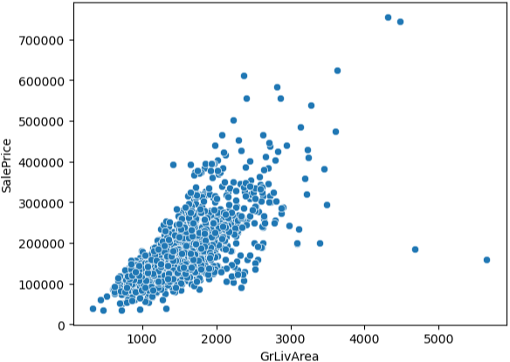

- Feature Selection
Important features influencing house prices were selected to improve model performance.

- Model Training
Machine learning models were trained using:

- Linear Regression - The process of predicting the value of a variable depending upon the value of some other variable is known as linear regression analysis. The variable that needs to be predicted is termed as the dependent variable while the variable used for prediction is referred to as the independent variable.
- Random Forest Regressor - Random forests are an ensemble learning method that constructs multiple decision trees on randomly selected subsets of the training set and then takes the average of the predictions in order to enhance prediction accuracy and prevent overfitting. The trees in the random forest select the optimal splitting criteria, which is the same as using splitter='best' for DecisionTreeRegressor. The size of the subset can be configured via the max_samples argument when bootstrap=True (which is the default setting).

- Model Evaluation
Models were evaluated using:

- Mean Absolute Error (MAE) - The mean absolute error (MAE) is the average of the sum of the absolute difference between the actual value and the predicted value.
- R² Score - R squared is an indicator of how well a model fits a set of data points. In regression, the R squared is the statistical measure used to determine how well the regression predictions fit the actual data points. If the R squared is equal to 1, the predictions fit the data perfectly.

- Model Performance
Model | R2 Score | MAE | Performance
Linear Regression | 79% | 25319.86 | Moderate Accuracy
Random Forest Regressor | 89% | - | High Accuracy

- Results
The prediction model generated is able to predict house prices from the feature inputs effectively.

Key observations:
- Large square footage leads to high house prices
- There is high correlation between overall quality and prices
- Random Forest produces more consistent predictions

- Conclusion
The machine learning project described here shows the use of the technology in the prediction of housing prices using critical property information.

Machine learning uses algorithms which provide a data-oriented approach and minimize human error in valuation processes.

- Future Improvements

To enhance the project, the following improvements can be made:
- Include geographic location data
- Apply advanced models (XGBoost, Gradient Boosting)
- Perform hyperparameter tuning
- Deploy as a full web application
- Add real-time prediction interface

